Automatic selection of classifier training images

According to the extracted bounding boxes’ images from original dataset frames, the histogram of both dimensions (width and height) is shown in “fig. 1“. It is then used to calculate the average dimensions to unify all images to it.

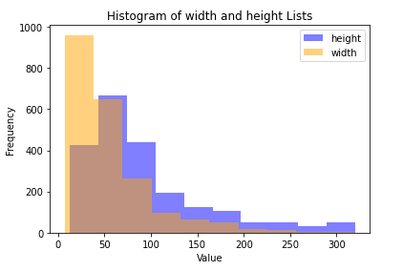
- The histogram of both dimensions (width and height) of the images used to train the classifier deducted from the two-classes dataset original images of size (320×320). The results are: (avg hight = 93.03 , avg. width = 55.86 , new diminsion = 60×60)

